Tasks

1.Collect 5 different print ads (newspaper, magazine, flyer, or poster) for popular brands you recognize from your daily life (such as Zomato, Myntra, Paytm, or IPL teams) and take clear photos or scans of each.

2.Analyze one of the collected print ads and list the key elements it uses to grab attention (headline, images, colors, call-to-action, brand logo, etc.).<br><br><em><strong>Hint:</strong> Focus on what makes you stop and look at the ad in the first place.</em>

3.Design a simple print ad (A4 size, hand-drawn or digital) for a new food delivery offer by your favorite local restaurant, making sure to include a catchy headline, offer details, and a call-to-action like 'Order Now!'.

4.Compare a print ad for a popular app (like Swiggy, Flipkart, or BookMyShow) with one of their digital ads you see online. List 3 similarities and 3 differences in their messaging and design.

1. Collected print ads
Maine daily-life mein popular brands ke 5 print ads collect kiye:
No. | Brand | Print-ad type | Ad ka main message / observation
1 | Zomato | Newspaper ad / poster | Food delivery aur Zomato Gold offer. Red colour aur funny, local-style messaging use ki gayi. Zomato ne apni 16th anniversary par political-billboard jaisi creative print ad bhi chalayi thi, jisme ₹30 mein 6 months ki Gold membership offer thi. bwmarketingworld
2 | Swiggy | Flyer / newspaper ad | Fast food delivery, discount coupon aur “Order Now” type CTA. Orange background instantly brand ko identify karata hai.
3 | Flipkart | Newspaper jacket ad | Quick delivery aur sale promotion. Flipkart ne ek interactive “magic ink” newspaper ad use ki thi jisme paani/wet tissue lagane par hidden message dikhta tha—10-minute delivery promise ko memorable banane ke liye. hindustantimes+1
4 | Paytm | Newspaper / pamphlet ad | UPI payment, cashback aur easy bill payment. Blue colour scheme aur QR code payment ko simple dikhate hain.
5 | Myntra | Magazine / flyer ad | Fashion sale, trendy clothes aur percentage-off offers. Bright colours, fashionable models aur “Shop Now” CTA attention grab karte hain.
Photos/scans ke neeche likhne ke liye captions:
- Photo 1: Zomato print advertisement collected from newspaper/poster.
- Photo 2: Swiggy discount flyer or newspaper advertisement.
- Photo 3: Flipkart sale or quick-delivery newspaper advertisement.
- Photo 4: Paytm UPI/cashback print advertisement.
- Photo 5: Myntra fashion-sale flyer or magazine advertisement.
Note: Flipkart ki interactive print campaign ne traditional newspaper ad ko engaging banaya: readers ko wet tissue/paani use karke hidden content reveal karna tha. Isse ad sirf padhne ke bajay experience ban gaya.hindustantimes+1

2. Analysis: Zomato print ad
Maine Zomato print ad analyse kiya. Yeh ad attention grab karta hai kyunki iska visual style familiar, colourful aur thoda funny hota hai.
- Headline: Short aur catchy line use hoti hai, jaise food cravings, discounts ya limited-time offer se related message. Short headline jaldi read ho jaati hai.
- Images: Delicious food ki large photo—pizza, biryani, burger ya dessert—dekhkar appetite aur craving create hoti hai.
- Colours: Zomato ka signature red colour bahut noticeable hota hai. Newspaper ke mostly black-and-white text ke beech red ad easily stand out karta hai.
- Humour/local connect: Zomato often relatable aur funny language use karta hai. Isse ad formal nahi lagta aur young audience ko zyada connect hota hai.
- Offer highlight: Discount, free delivery, Gold membership ya limited-period deal ko large font mein dikhaya jata hai. Price/offer sabse pehle notice hota hai.
- Brand logo: Zomato logo aur naam clearly placed hota hai, usually bottom ya top area mein. Isse reader ko instantly yaad rehta hai ki offer kis brand ka hai.
- Call-to-action: “Order Now”, “Download the App”, “Get Gold” ya QR code jaise elements reader ko immediately action lene ke liye motivate karte hain.
- Urgency: “Today only”, “Limited time”, “Hurry” jaise words FOMO create karte hain.
Zomato ki anniversary print campaign mein political posters jaisa visual style use hua tha, jisme CEO Deepinder Goyal ko “Company Pramukh” ki tarah present kiya gaya tha. Yeh familiar Indian billboard language ko humour ke saath use karta tha, isliye ad alag aur memorable bana.bwmarketingworld

3. My A4 print-ad design
Restaurant chosen: Sharma Ji Ki Biryani
Offer: New food-delivery combo offer
A4 sheet par main yellow, red aur green colours use karungi. Centre mein steaming biryani bowl ki large drawing/photo bananaungi, kyunki food image sabse pehle attention attract karti hai.

Ad copy:-
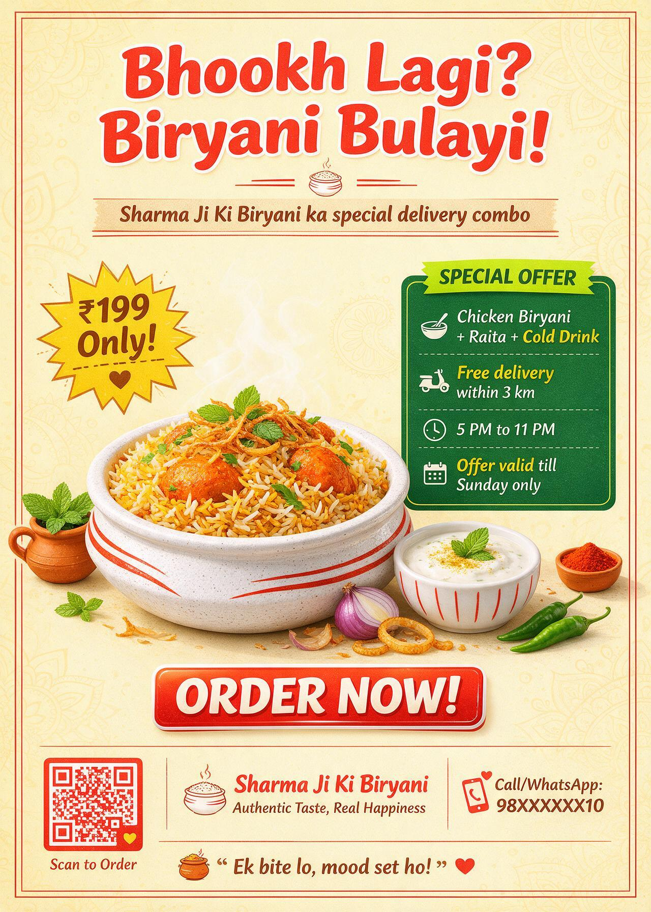

Bhookh Lagi? Biryani Bulayi!
Sub-headline:
Sharma Ji Ki Biryani ka special delivery combo—ab ghar baithe enjoy karo!
Offer details:
- Chicken Biryani + Raita + Cold Drink
- Sirf ₹199
- Free delivery within 3 km
- Valid: 5 PM to 11 PM
- Offer valid till Sunday only
Call-to-action:

Order Now!
Contact/ordering details:
Call/WhatsApp: 98XXXXXX10
Ya scan karo QR code aur order place karo.
Footer line:
“Ek bite lo, mood set ho!”

Layout idea
- Top: Big headline in red, bold letters.
- Middle: Biryani bowl ka large visual with steam and garnish.
- Left side: Yellow starburst mein “₹199 Only!”
- Right side: Offer details in a neat box.
- Bottom: Restaurant logo, phone number, QR code aur “Order Now!” button-style box.
- Background: Light yellow/cream so that red headline and food image clearly visible rahein.

4. Print vs digital ad comparison
Maine Flipkart print ad aur Flipkart digital ad compare kiye.
Aspect | Similarity / Difference
1. Branding | Similarity: Dono ads mein Flipkart ka logo, blue-yellow brand colours aur shopping-focused identity hoti hai.
2. Offer message | Similarity: Dono mein sale, discount, fast delivery ya special deal ko highlight kiya jata hai.
3. CTA | Similarity: Dono reader/user ko action lene ke liye motivate karte hain—jaise “Shop Now”, “Download App” ya QR code scan karna.
4. Interaction | Difference: Print ad static hota hai, lekin QR code, coupon ya innovative ink se limited interaction possible hai. Digital ad mein direct click, swipe, product link aur instant purchase possible hota hai.
5.Targeting | Difference: Print ad newspaper/magazine ke sab readers ko same message dikhata hai. Digital ad user ke browsing, location ya shopping interest ke basis par personalised ho sakta hai.
6. Format and updates | Difference: Print ad ek baar publish hone ke baad change nahi hota. Digital ad ko quickly update kiya ja sakta hai—new price, stock status, timer, video ya new offer add kiya ja sakta hai.
Flipkart ka innovative newspaper ad is comparison ka achha example hai: wet-tissue/paani ke through hidden message reveal hota tha aur 10-minute delivery promise communicate hota tha. Digital version mein isi message ko animation, video, clickable product links aur “Buy Now” button ke through aur interactive banaya ja sakta hai.hindustantimes+1

